1. ggplot(Marks,aes(x=Serial, y=Midterm, color=Total, size=5))+geom_point()

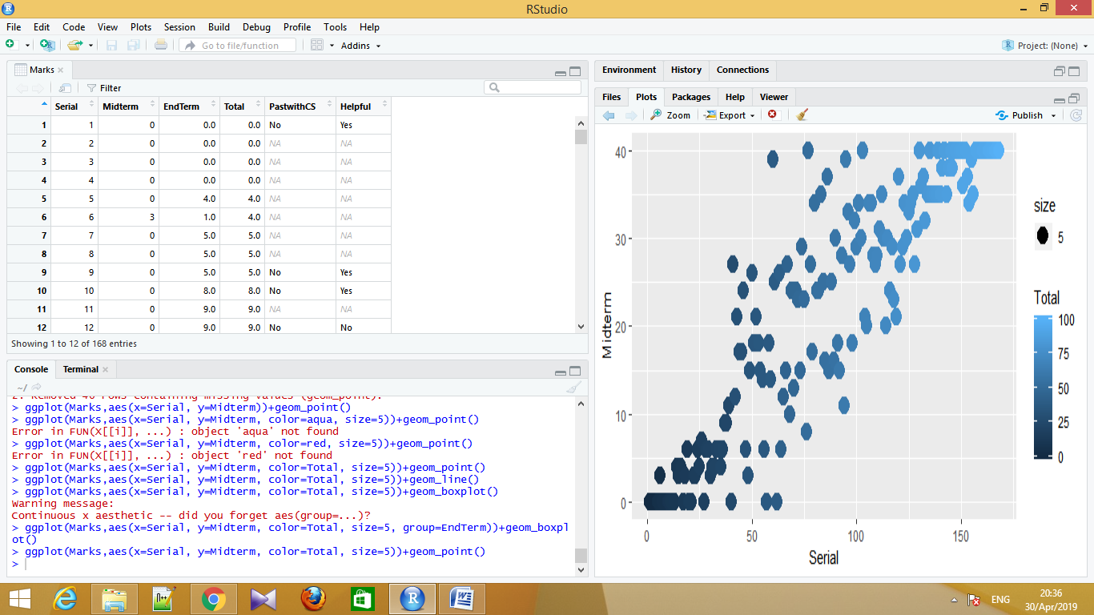

Converting To Log :-

ggplot(Marks,aes(x=log(Serial), y=log(Midterm), color=Total, size=5))+geom_point()

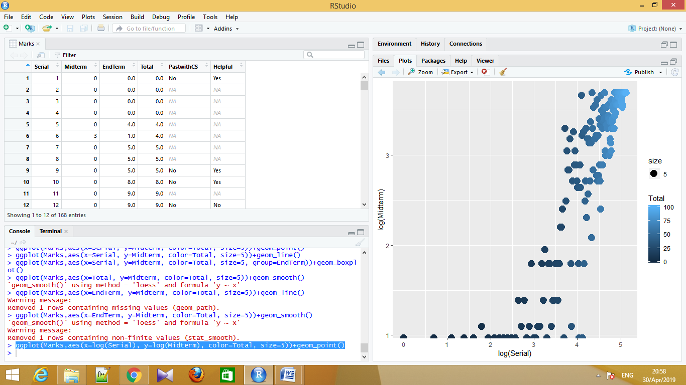

2. ggplot(Marks,aes(x=Serial, y=Midterm, color=Total, size=5))+geom_line()

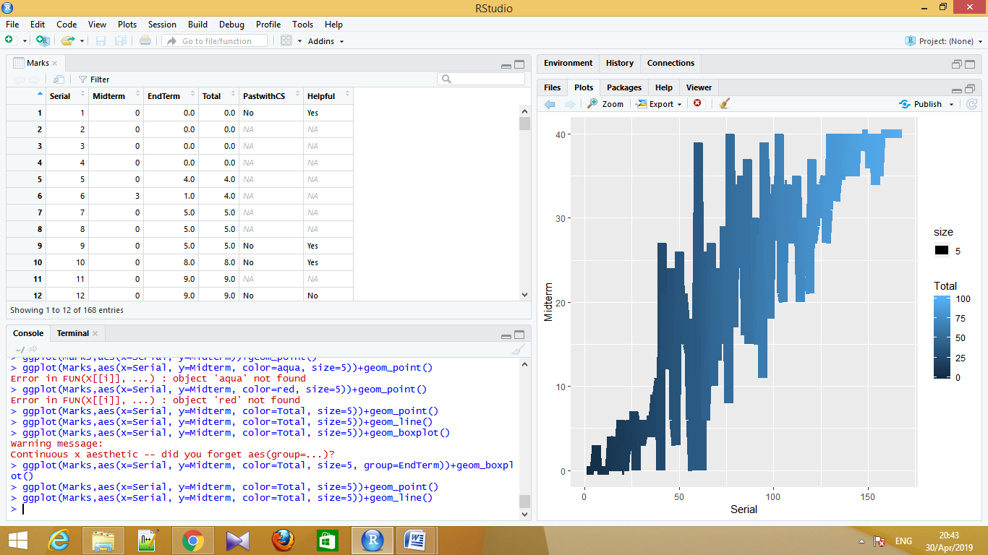

Converting To Log :-

ggplot(Marks,aes(x=log2(EndTerm), y=log(Midterm), color=Total, size=5))+geom_line()

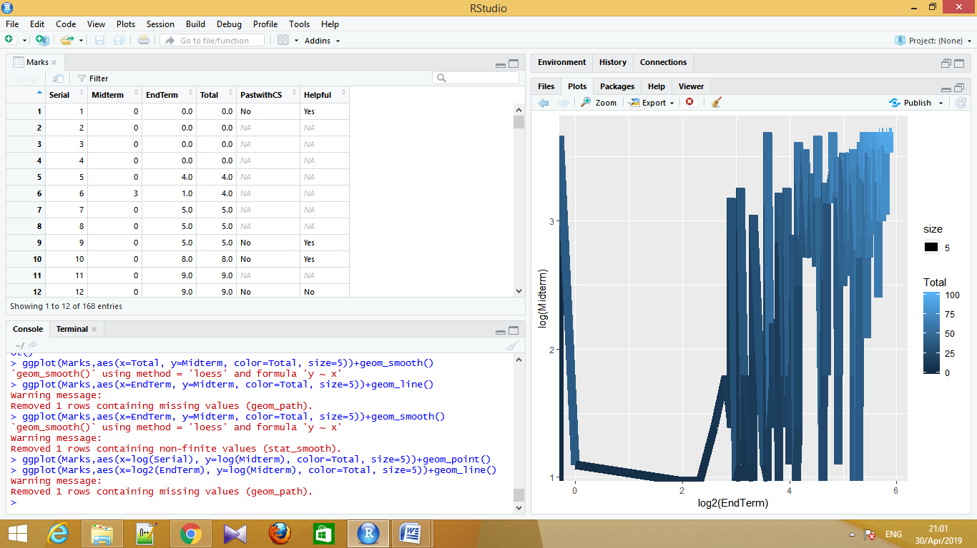

3. ggplot(Marks,aes(x=Serial, y=Midterm, color=Total, size=5, group=EndTerm))+geom_boxplot()

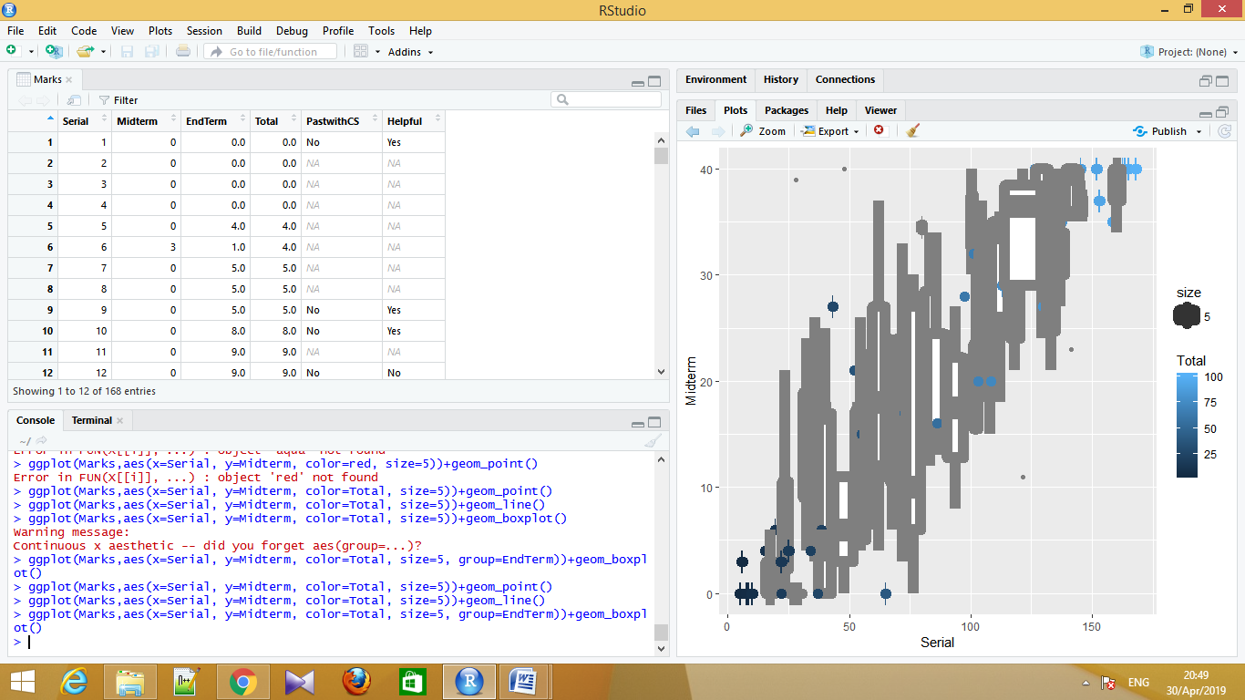

Converting To Log :-

ggplot(Marks,aes(x=log(Serial), y=log(Midterm), color=Total, size=5, group=EndTerm))+geom_boxplot()

